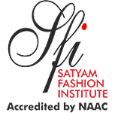

**SATYAM FASHION INSTITUTE, NOIDA**

**Reaccredited by NAAC 'A' Grade, CGPA 3.18**

**Affiliated with SNDT University, Mumbai**

7.2 Best Practices: Environmental and Social Consciousness

Best Practice 1: Environmental and Social Consciousness

The Objective is to -

* Increase environmental awareness among all stakeholders.
* Promote green policies among students and faculty.
* Disseminate environmental literacy and motivate sustainable practices.
* Establish efficient waste management and recycling systems.
* Optimize energy utilization on campus.
* Transform the campus into a pollution-free and environmentally friendly zone.
* Impart knowledge of green living among students, staff, and stakeholders.
* Foster social consciousness and community welfare values.
* Elevate environmental literacy and green policies among stakeholders.
* Optimize waste management and energy use.
* Foster sustainable practices and social consciousness across campus.

Context:

Since 2020, Satyam Fashion Institute (SFI) has been guided by a Green Policy that emphasizes energy conservation, water management, and waste reduction. Sustainability is integrated into the design curriculum, encouraging students to embrace eco-conscious practices and repurpose materials for innovative creations. Through various initiatives, SFI fosters a culture of environmental stewardship and social responsibility within the institution and the broader community.

The Practice

Various awareness drives, brainstorming sessions, and plantation drives were organized for society, stakeholders, and students in 2023-24.

Key Initiatives:

* Environmental Awareness through Plantation Drive:

Regular tree plantation drives, both on and off-campus, promote a greener environment. Annual funds are allocated for campus greenery maintenance.

* Save the Environment:

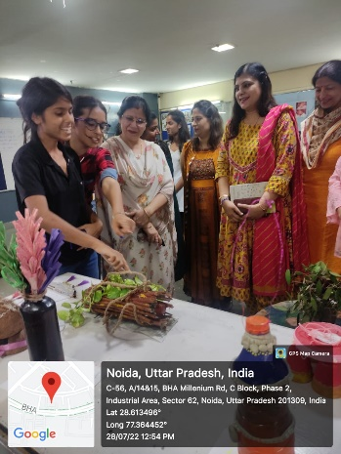On the occasion of World Environment Day 2023, SFI took the initiative of organizing a competition in both virtual and physical mode for the students and faculty members. A hierarchical approach is followed: Reduce, Reuse, Recycle.

* Energy Optimization:

The installation of 40 KW solar panels in 2018 harnesses renewable energy. LED lighting is used throughout the campus, and students are encouraged to conserve energy by switching off unused equipment.

* 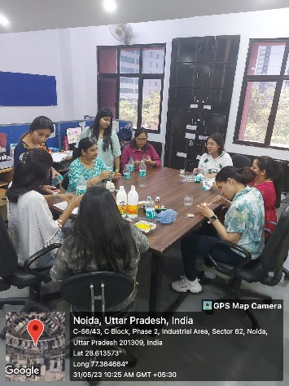Recycling Practices:

Students adopt green design thinking using sustainable materials (fabric, yarn, wood, clay, etc.). Some of these projects include converting old denim into bags, muslin toils into garments, and tyres into furniture just to name a few. In the graduation show of Triptych 2023, the design students of different departments especially Textile Design worked on upcycling and repurposing of craft and developed on the creative range for the show. The collection

* Social Engagements

**Student and staff participaton in the sustainable practices during various events**

The institute donated clothes and furniture to Gharonda Bal Ashram through Bharatpuria Education Society. We also implemented the Swachhata hi Sewa Abhiyaan, an initiative of GOI during the occasion of Gandhi Jayanti 2023. Regular practice of keeping water pots for passersby outside campus is being followed. The institute also supports local artisans by showcasing their work at institute events.

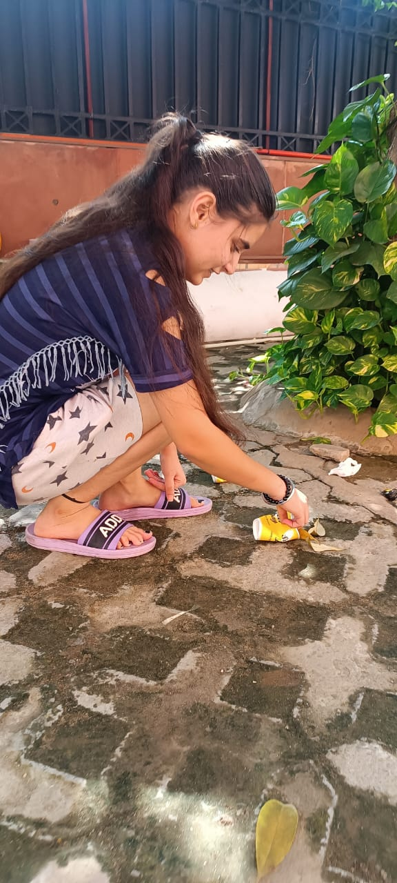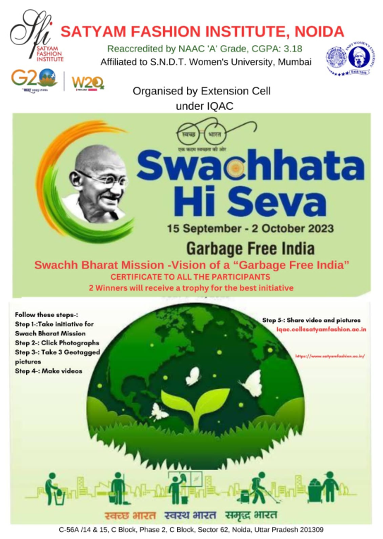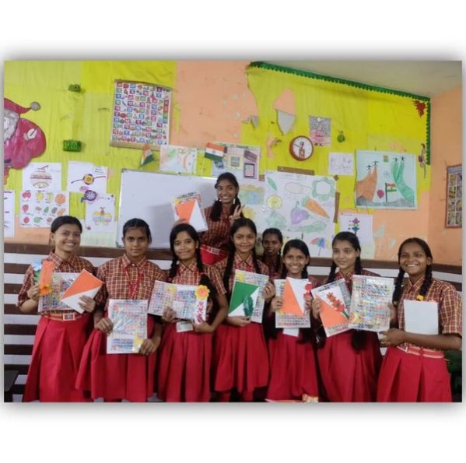

***Students engaged in various social awareness activities like plantation drive***

Evidence of Success

* Increased environmental and social consciousness among students and staff.
* Development of habitual energy-saving behaviors across the campus.
* Enhanced student creativity and cost-effective project completion.
* Active student participation in donation drives and community services.

Problems Encountered

* Daily waste segregation remains challenging.
* Awaiting approval for NSS unit registration.

Best Practice 2: Entrepreneurial and Skill Development Practices

The Objective is to -

* Provide earning opportunities while studying on campus.
* Offer hands-on training and work experience.
* Promote design thinking and media technology skills.
* Prepare students for employment through real-world exposure.
* Foster student involvement in institutional management.

The Practice

The “Earn While You Learn” scheme, launched by the institute in the year 2020, enables students to gain industry experience while studying. Students engage in social media management, graphic design, product development, and on-site projects.

Student Engagement and Industry Exposure:

Design students at SFI actively participate in a range of initiatives that combine learning with real-world experience.

* Student engagement extends beyond the classroom, encompassing participation in impactful initiatives such as managing social media campaigns and organizing exhibitions like HGH 2023 and the Diwali Exhibition. The "Upcycling Project," where students conceptualized and sold upcycled products, showcased their creativity and entrepreneurial spirit.
* The Earn While You Learn initiative further empowers students through counselling, mentoring, and freelance or part-time job opportunities after classes.
* In the academic session 2023-24, students collaborated on visual merchandising projects with industry expert Anup Banerjee and contributed to backstage and styling roles for various fashion shows, ensuring they are well-prepared for the dynamic industry ahead.
* During the academic year 2023-24, SFI recognized the achievements of 20 students by awarding them prize money for their outstanding contributions during the College development activities under Earn while you Learn scheme. 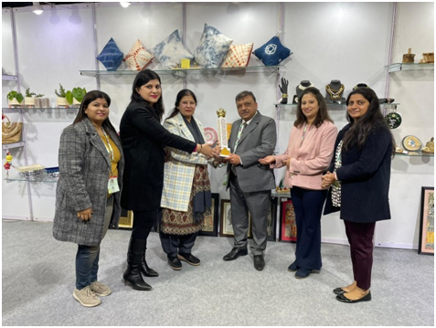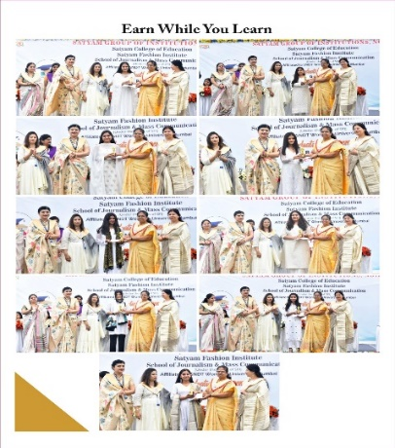

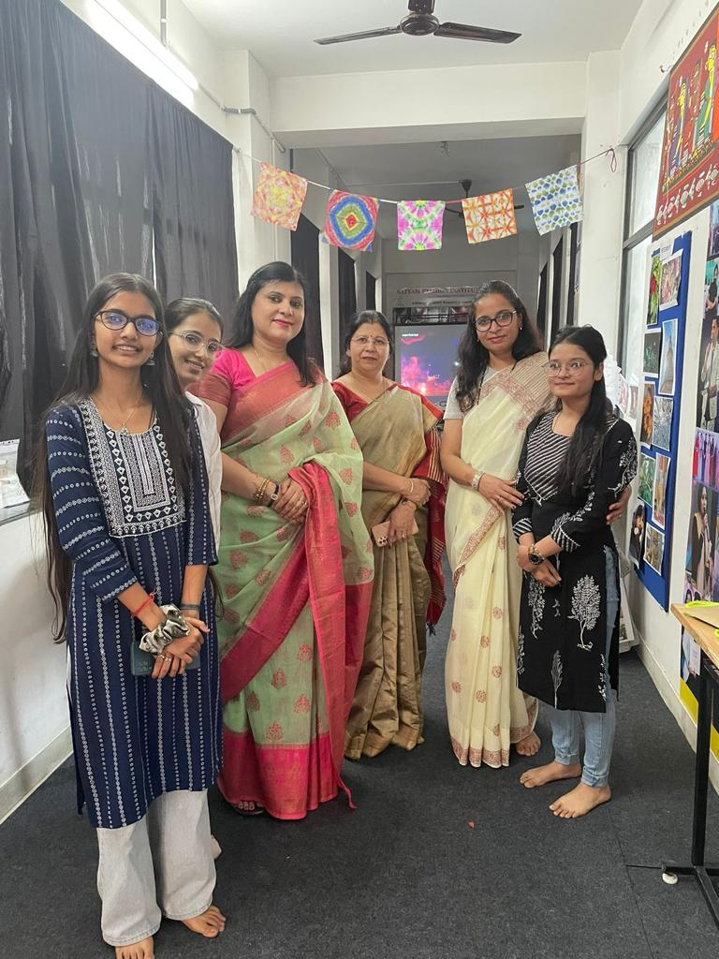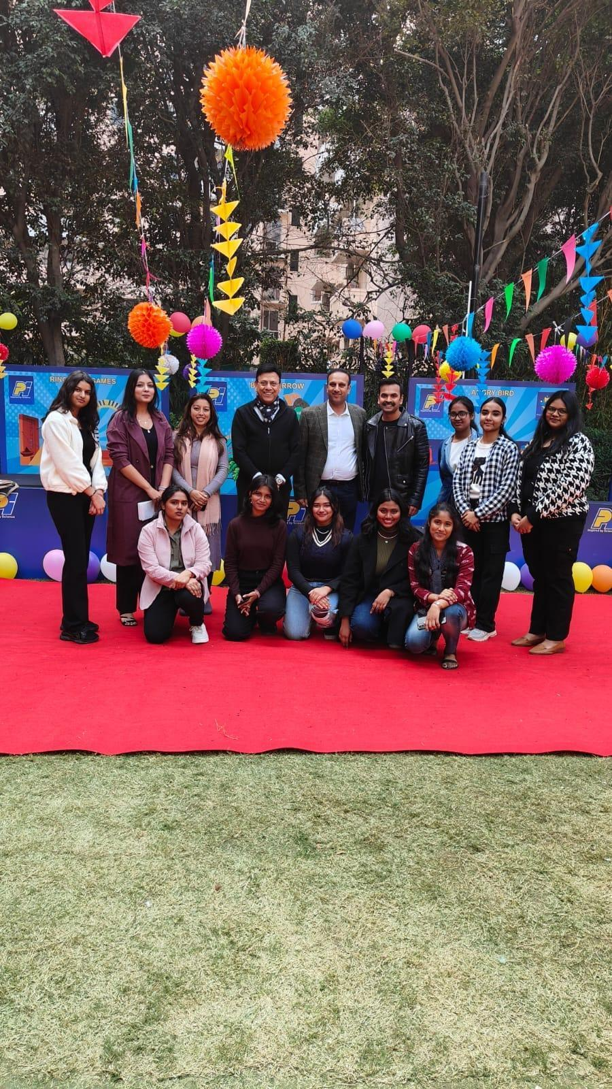

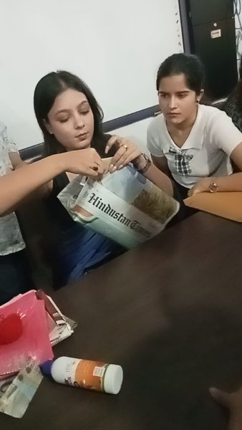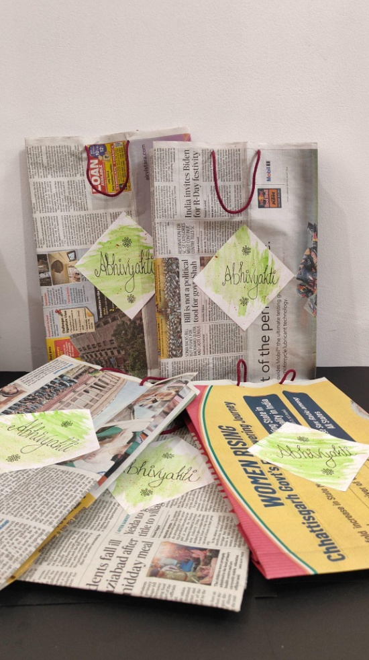

***Students’ participation in various entrepreneurial activities like HGH exhibition, earn while you learn, Diwali exhibition and upcycling projects***

Evidence of Success

* Increased student enrollment in entrepreneurial initiatives.
* Enhanced hands-on experience and confidence.
* Improved resumes and career exploration opportunities.
* Active participation in national and international exhibitions like HGH India and Sowtex Mill Meet.

Problems Encountered

* Late working hours limited by gender-specific constraints.
* Varying levels of student performance based on individual differences and ensuring equitable access to resources and support.